# SEO Analyzer User Guide

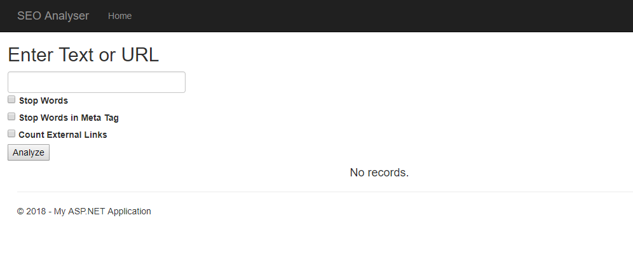

1. Enter text or URL in the given field
2. Select the option given from the checkbox provided
3. Click Analyze.

Example result:

